**Board Game Project**

**PHASE-1**

**Private environment through VPC: Using the default one**

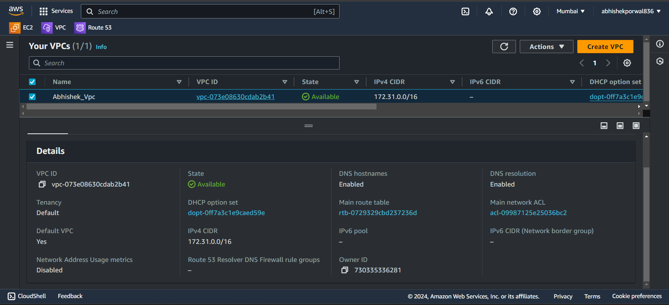

**Security Group:**

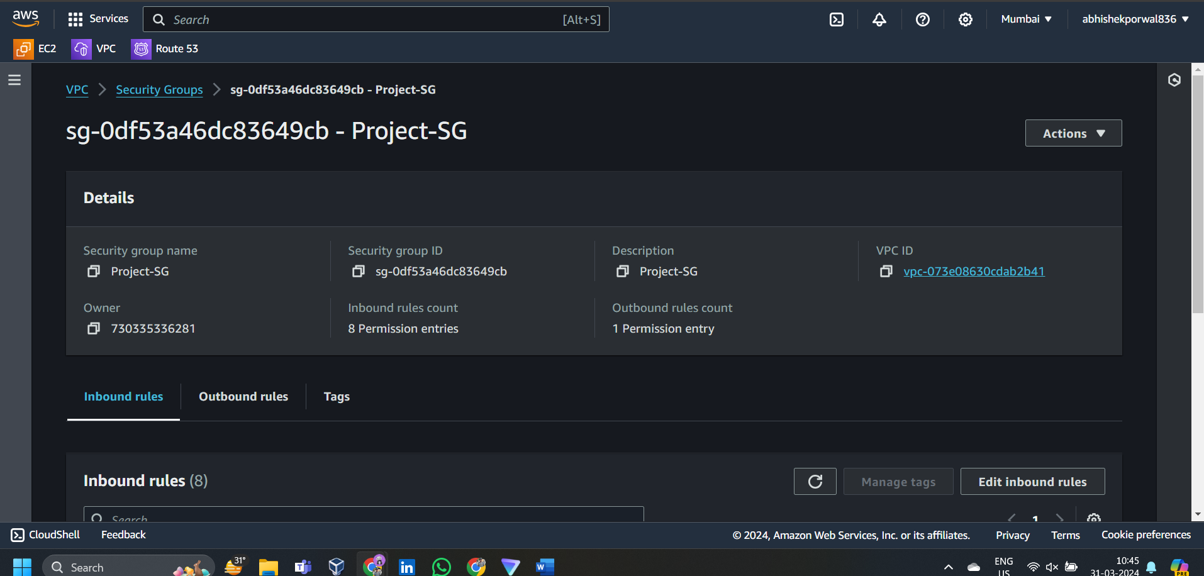

**Associate inbound rules**

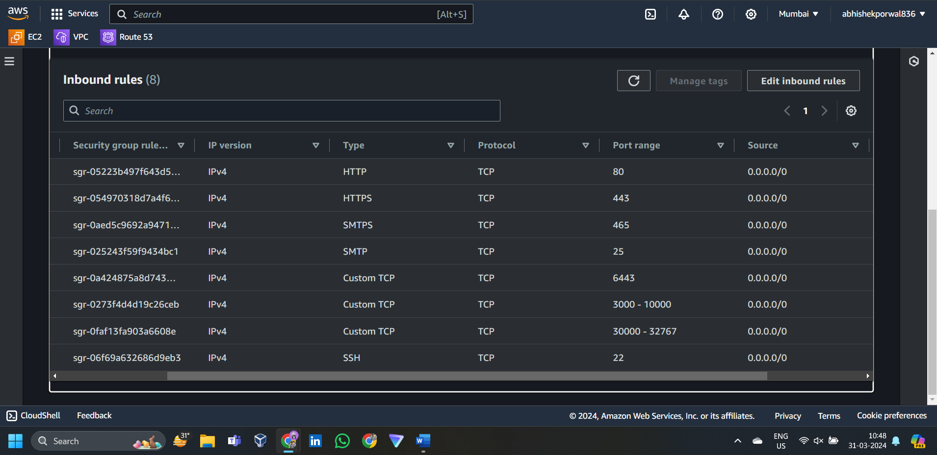

**VMs:3 vms for Kubernetes cluster:**

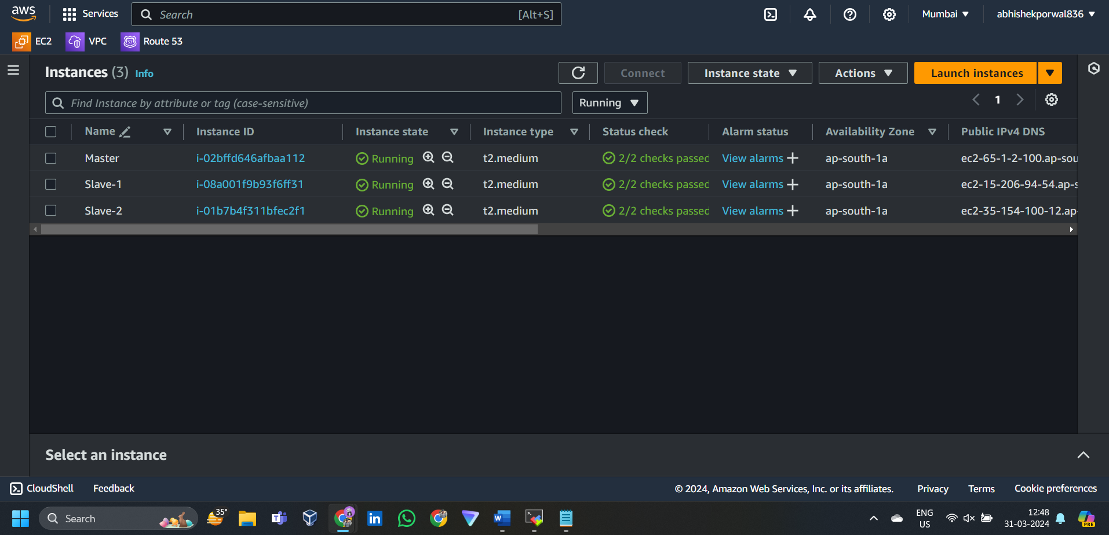

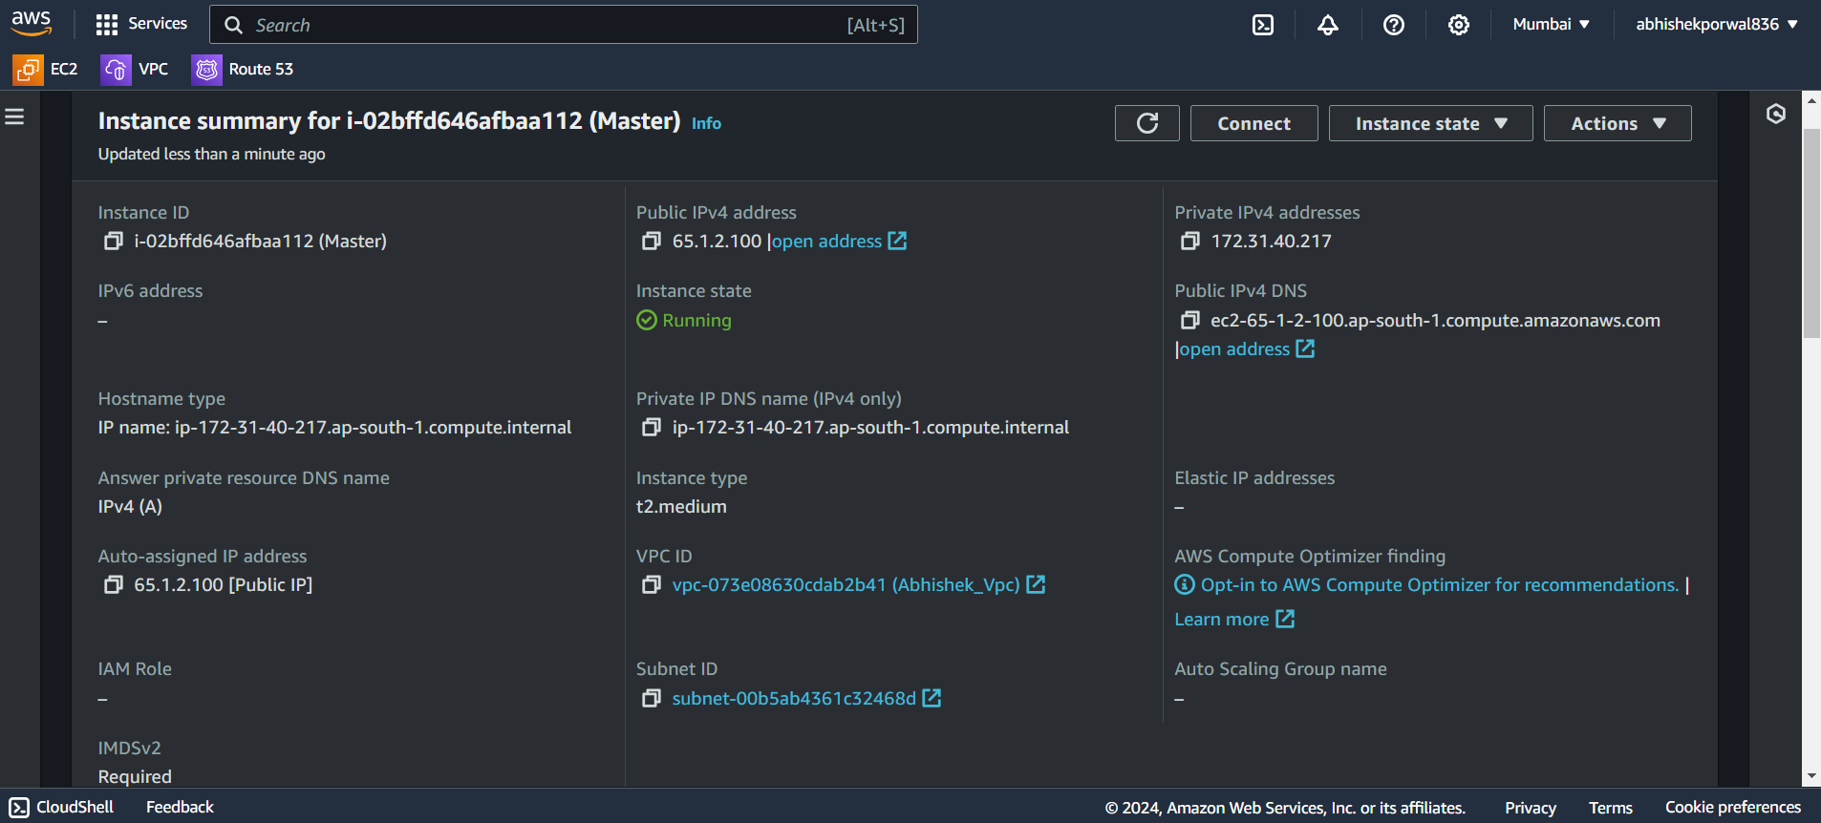

**SSH into the VM’s using MobaXterm:**

**Master-node:**

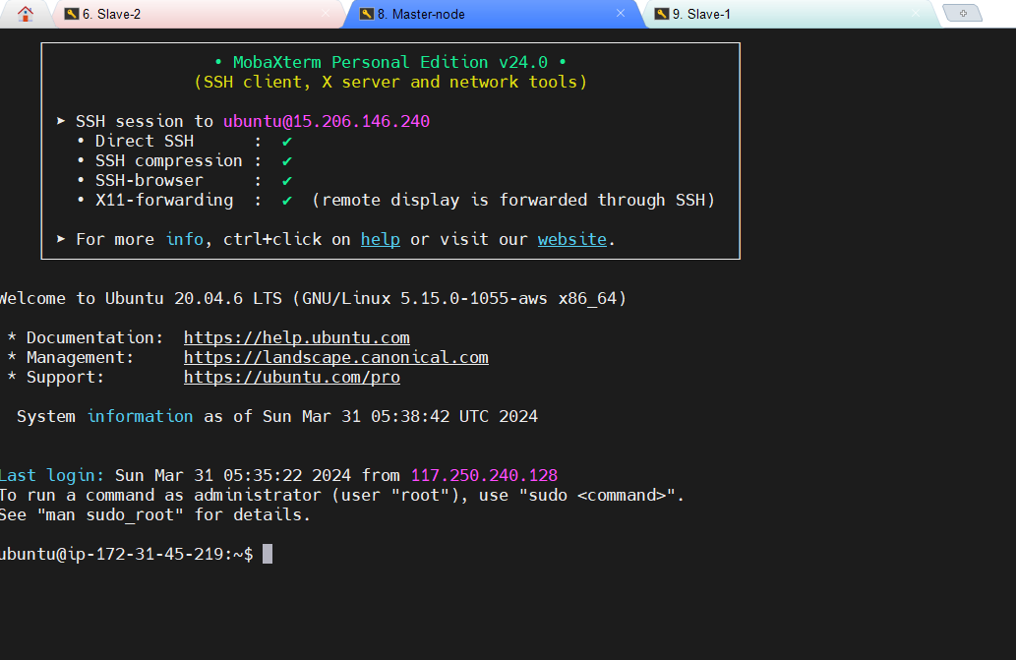

**Slave-1|:**

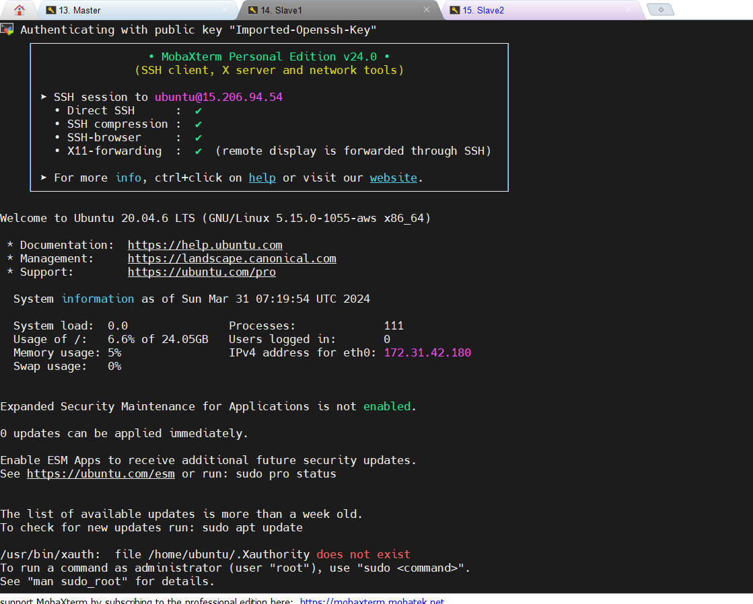

**Slave-2:**

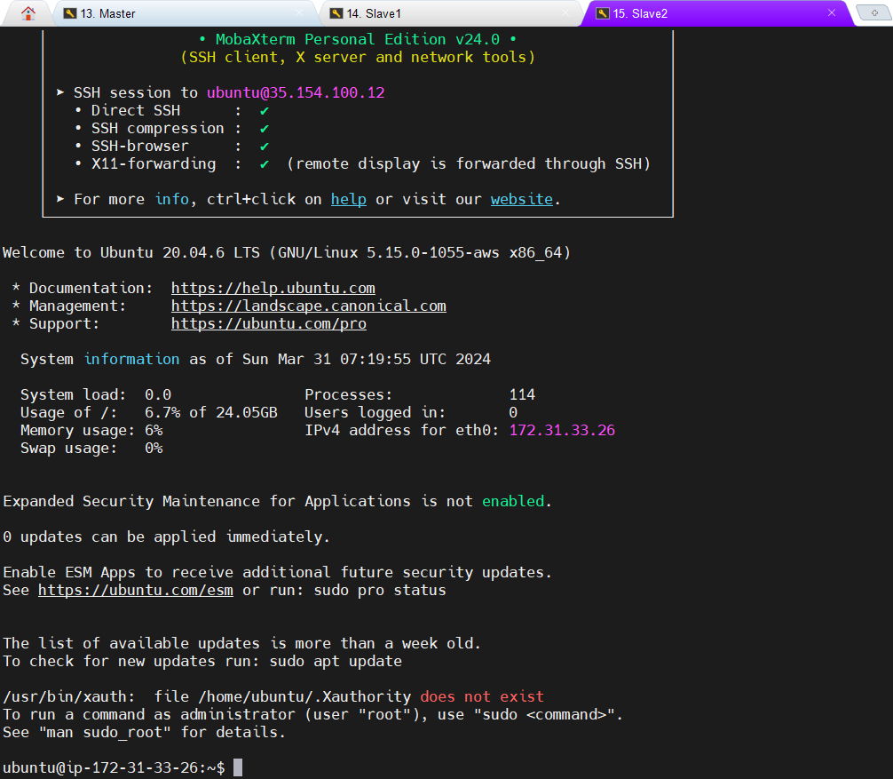

**sudo su: to become root user on each instance**Now we need to run the commands to install Kubernetes cluster:  
by creating shell script:

Vi 1.sh then save using :w nad exit using :wq

Give the executable permissions to the file using :

Chmod +x 1.sh

Execute the file : ./1.sh

**Setup K8-Cluster using kubeadm : refer that in phase 1**

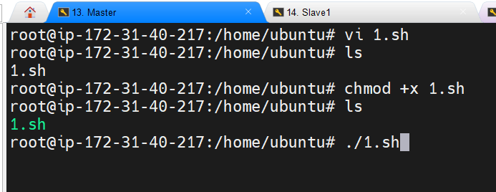

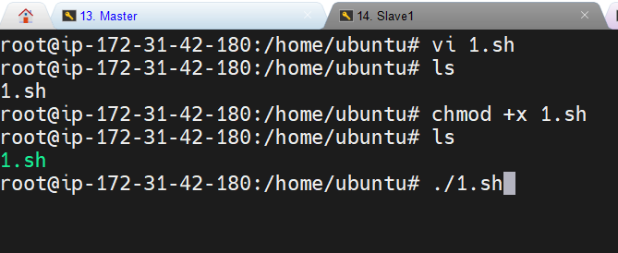

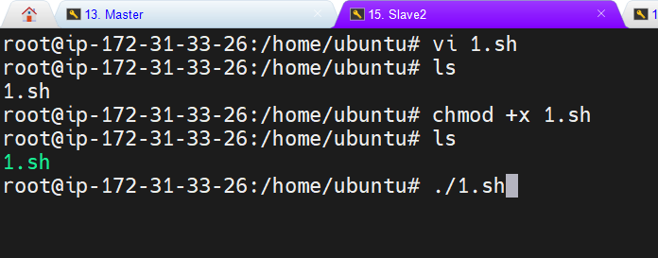

**Run the corresponding commands to setup the k8.  
after running sudo kubeadm init --pod-network-cidr=10.244.0.0/16 on master node we get**

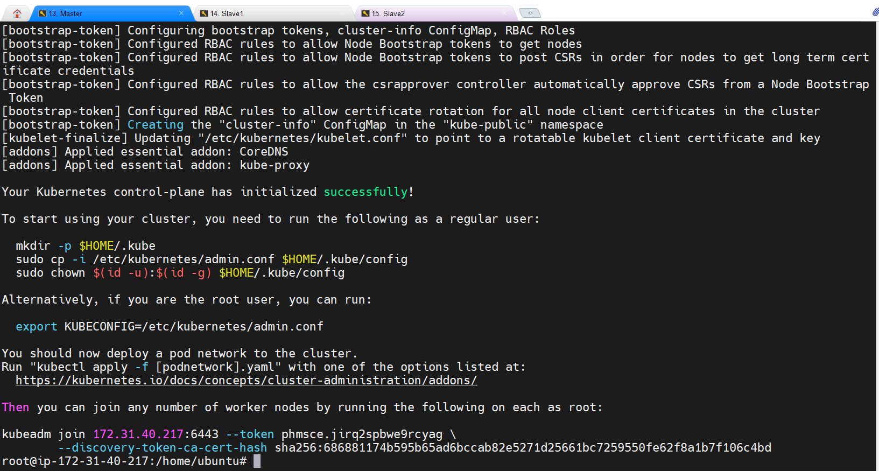

**On slave rode after running the command:**

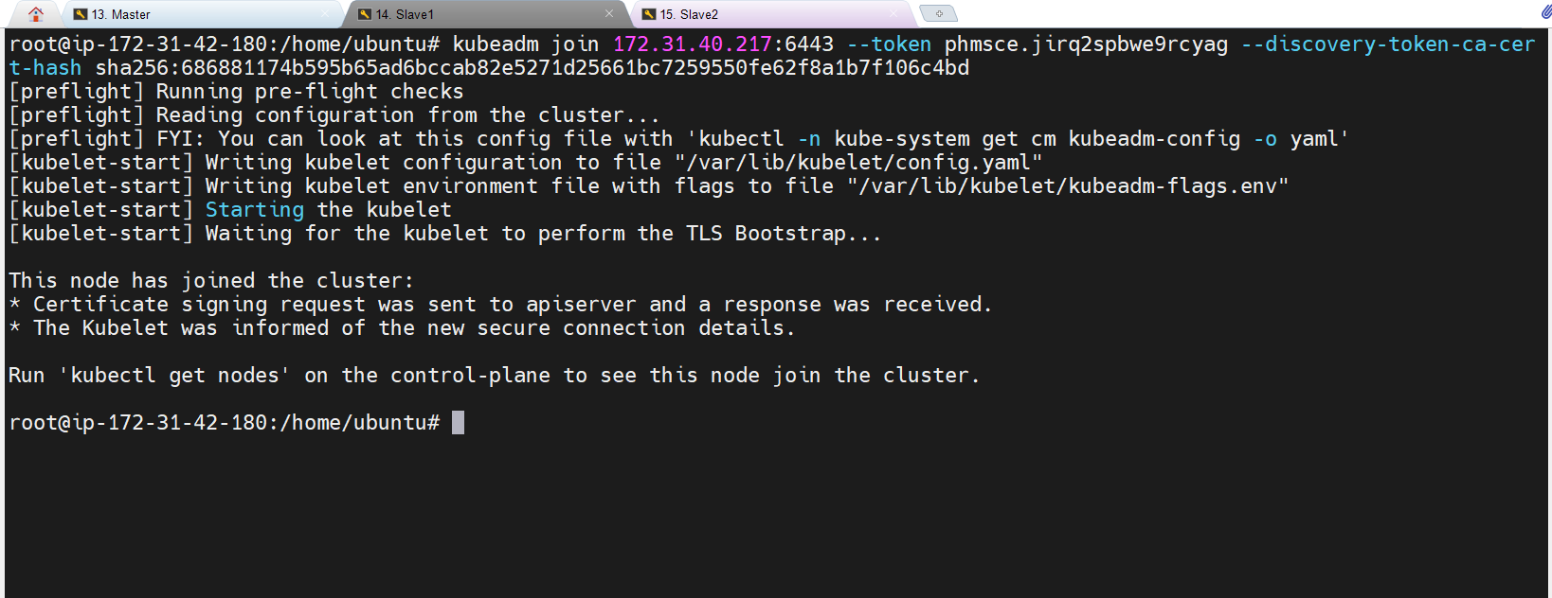

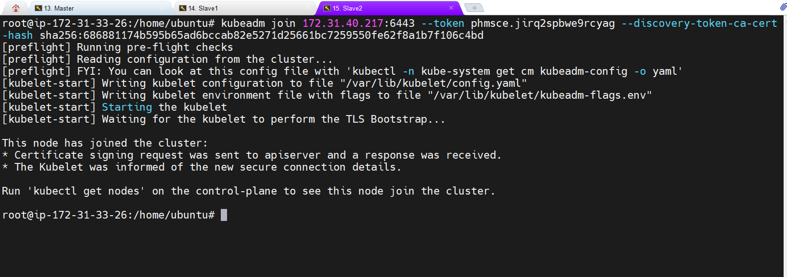

Getting the node

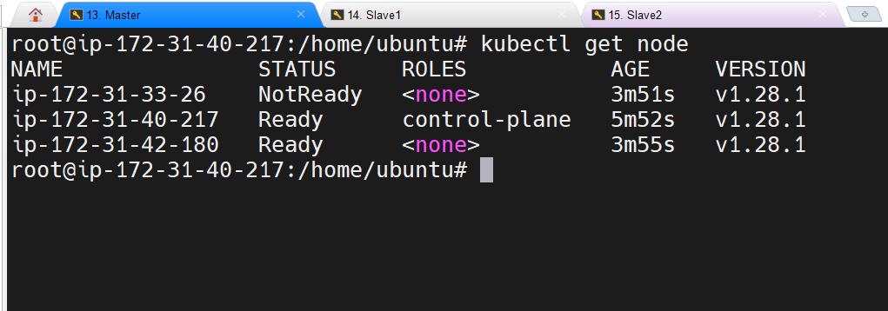

**KUBEAUDIT:**

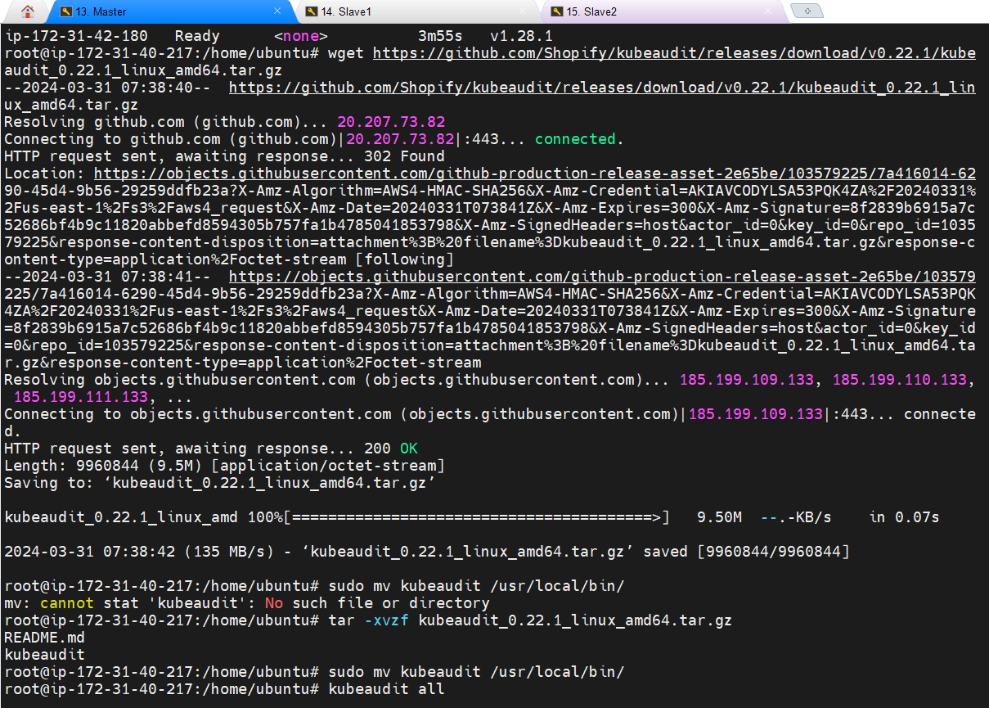

**Create sonarkube and nexus server and connect to them through MobaXterm:**

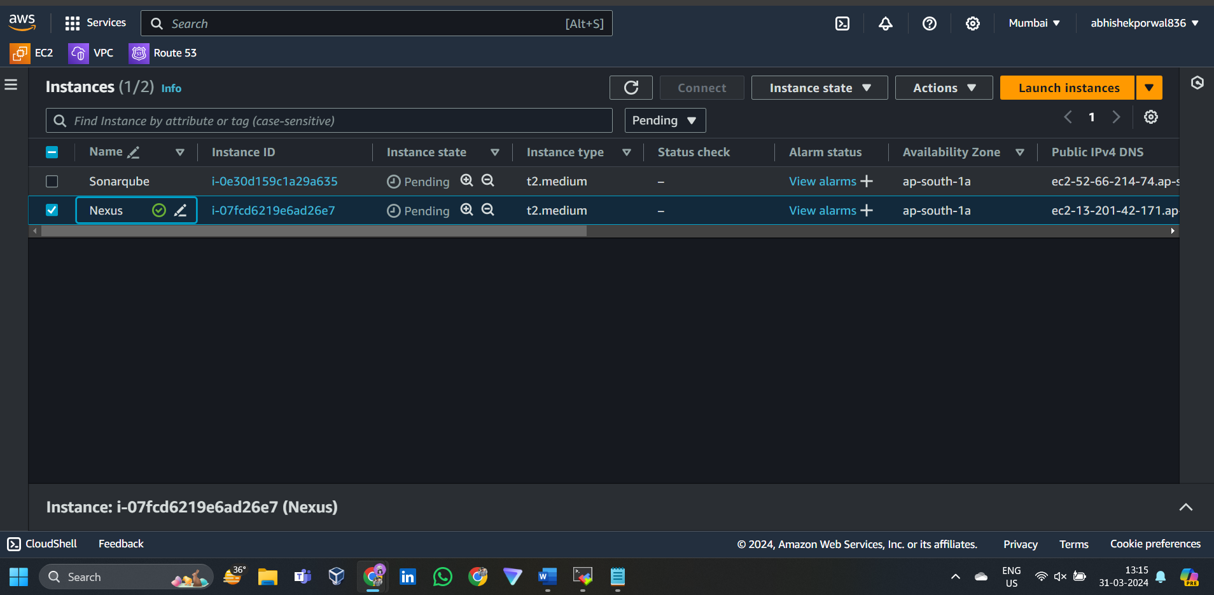

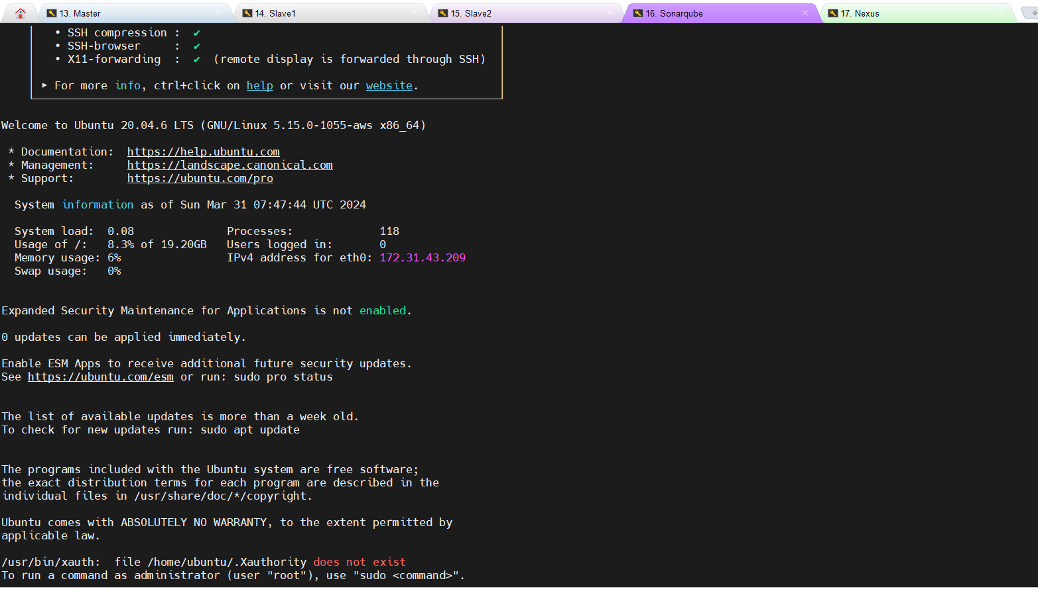

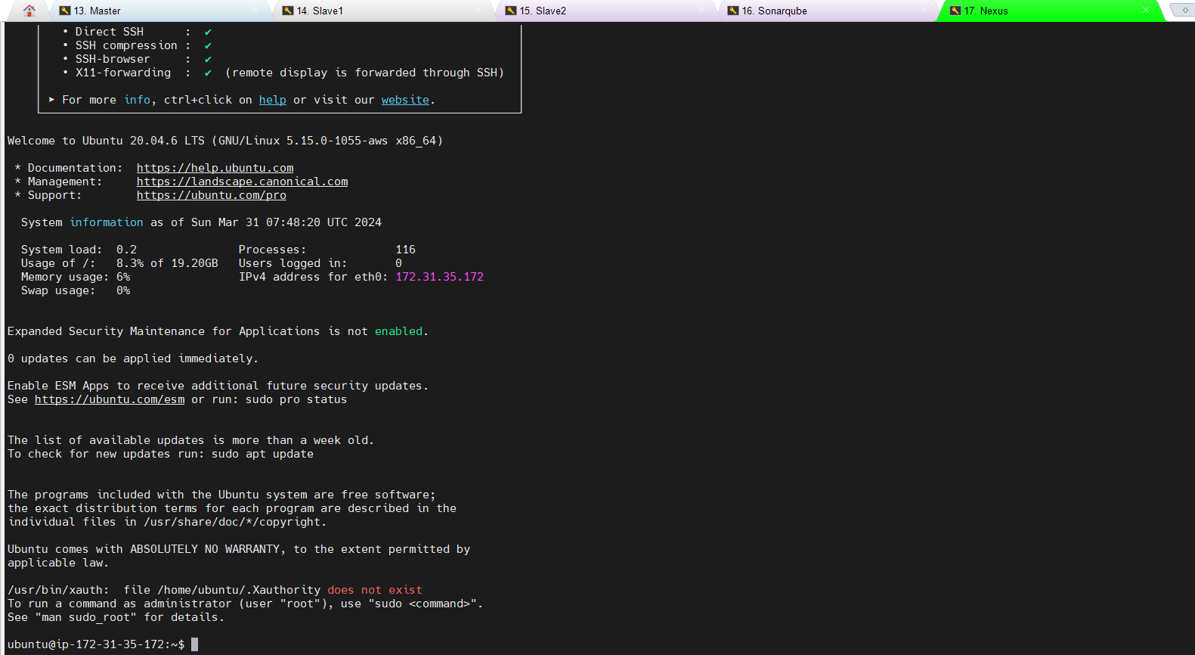

**Create Jenkins server and ssh into it through MobaXterm:**

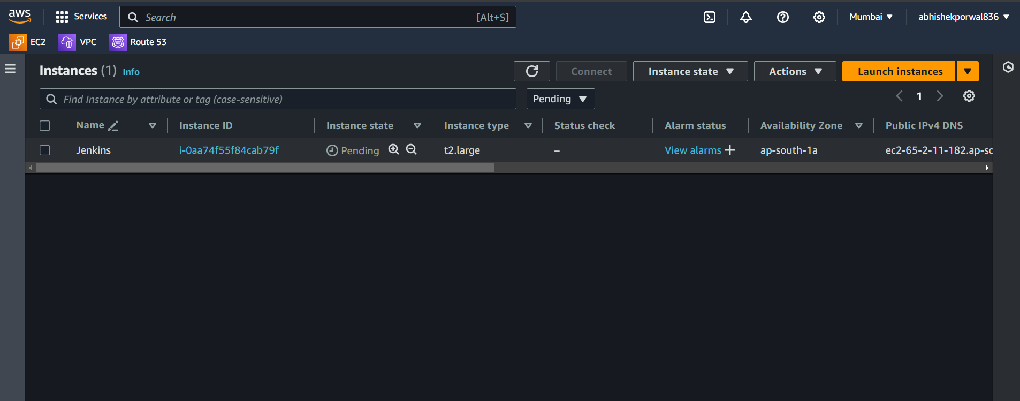

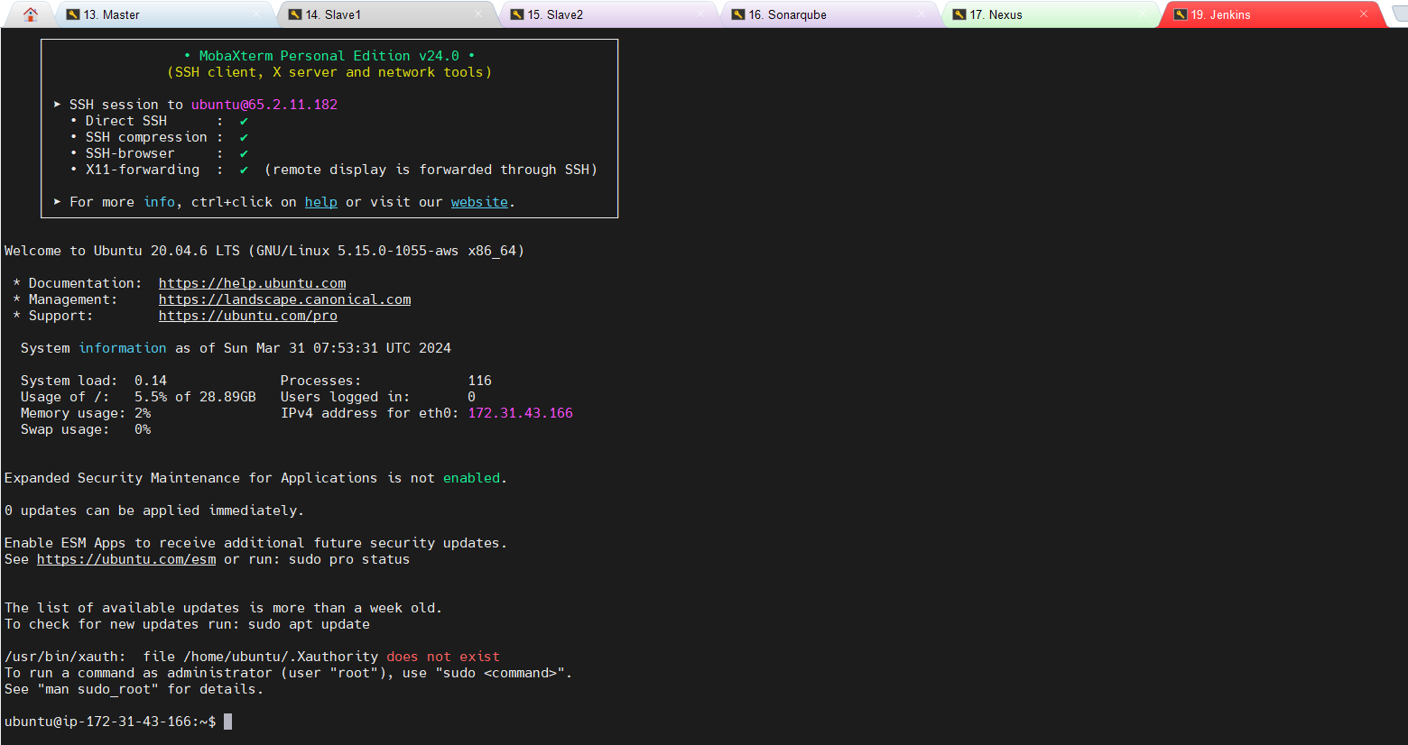

**Setting up Sonarkube :**

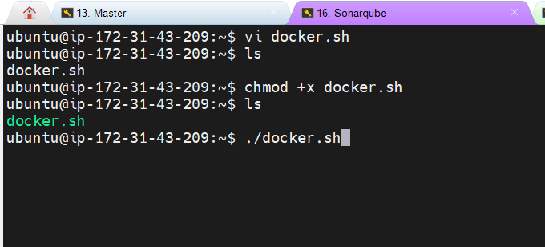

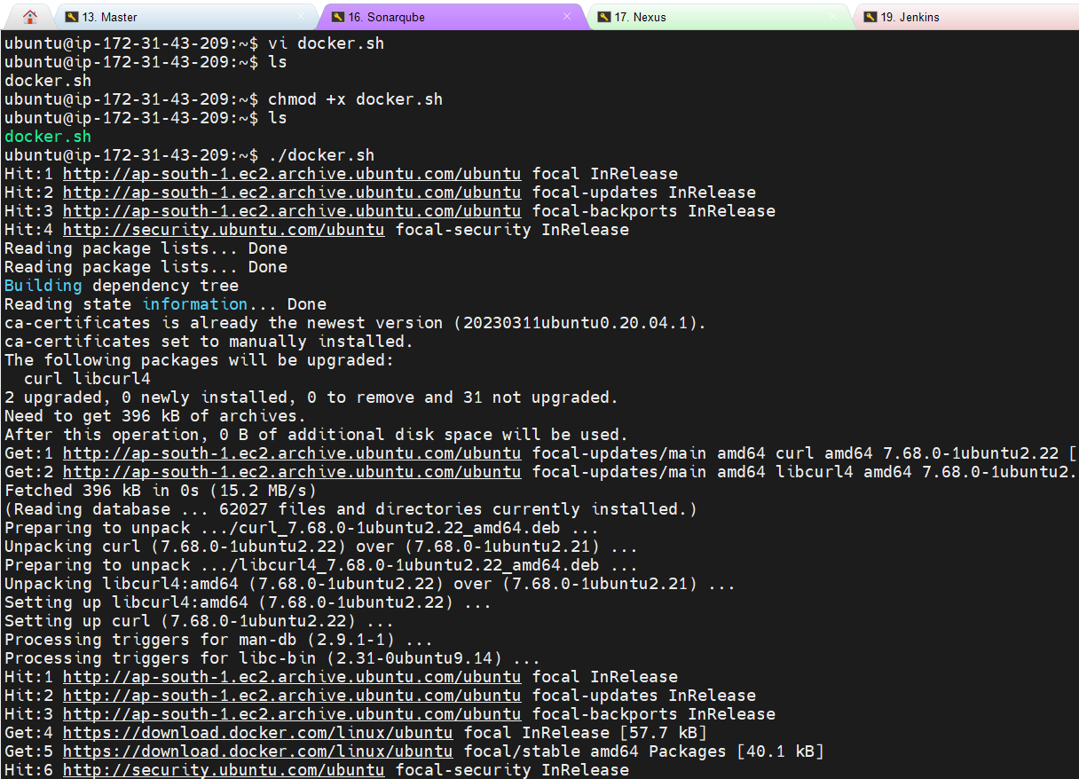

**Verifying docker is installed**

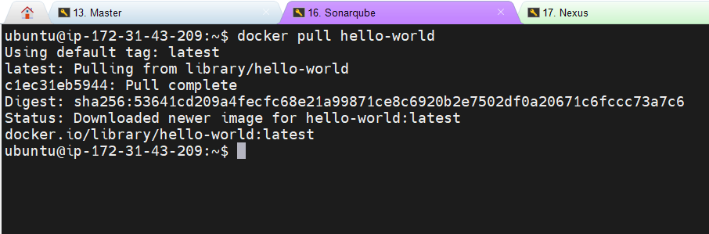

**Running docker container of sonarqube**

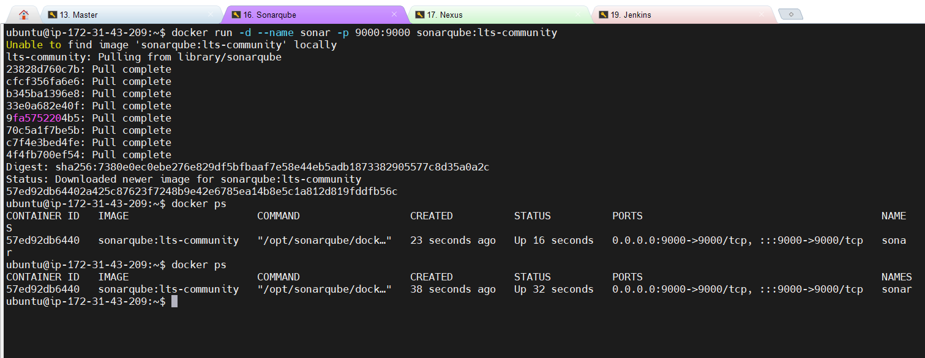

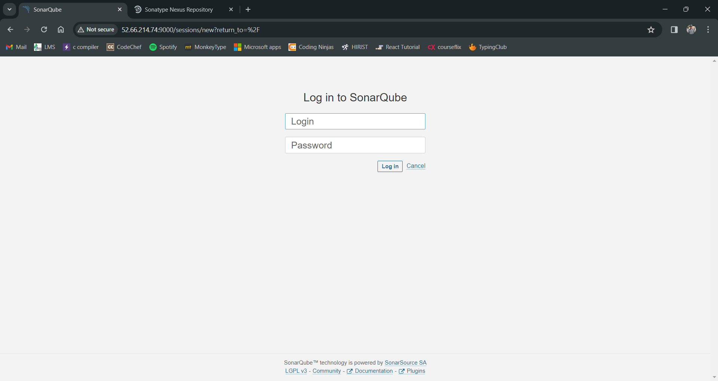

**Setting up Nexus:**

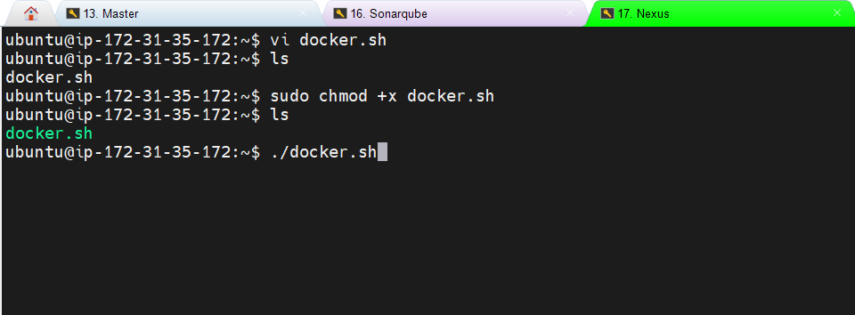

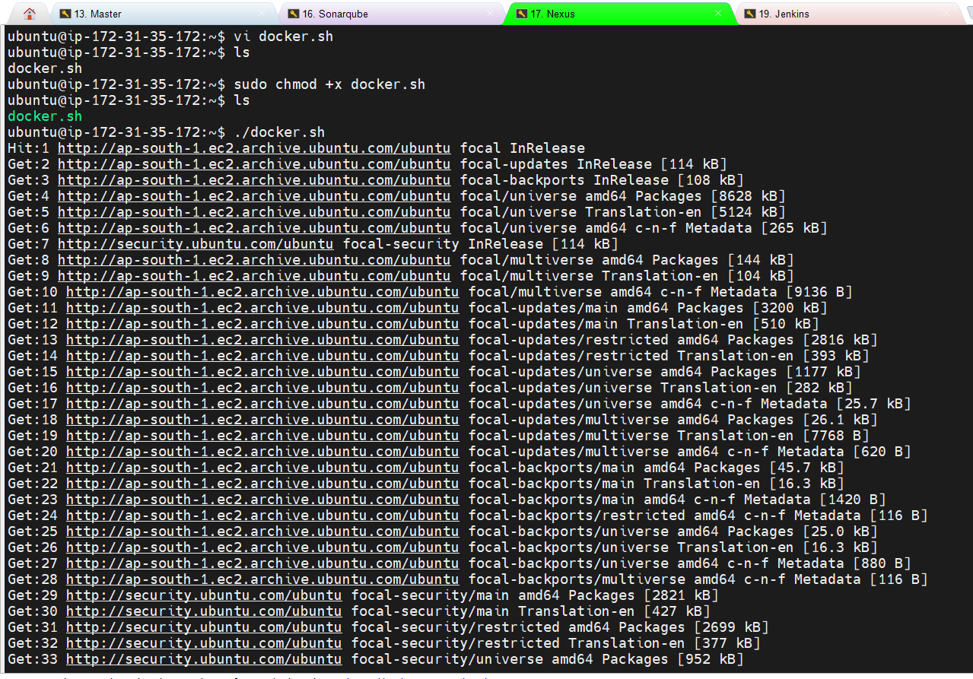

**Verifying docker is installed**

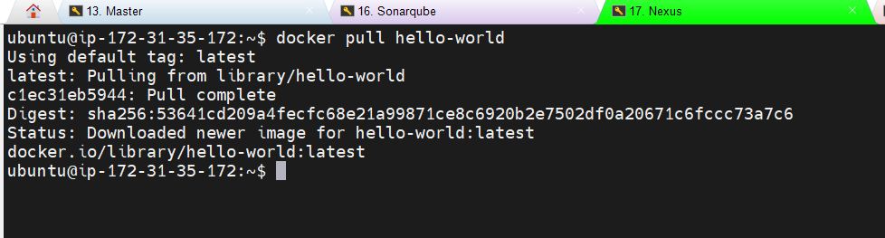

Run docker container of nexus:

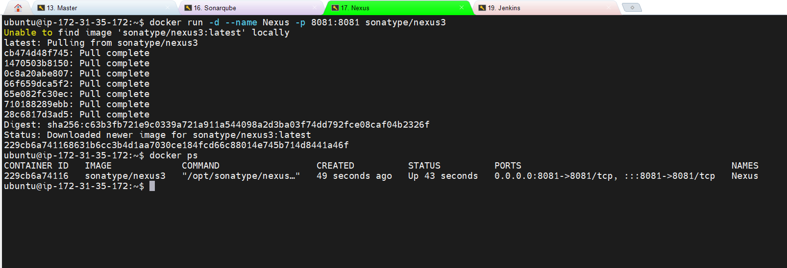

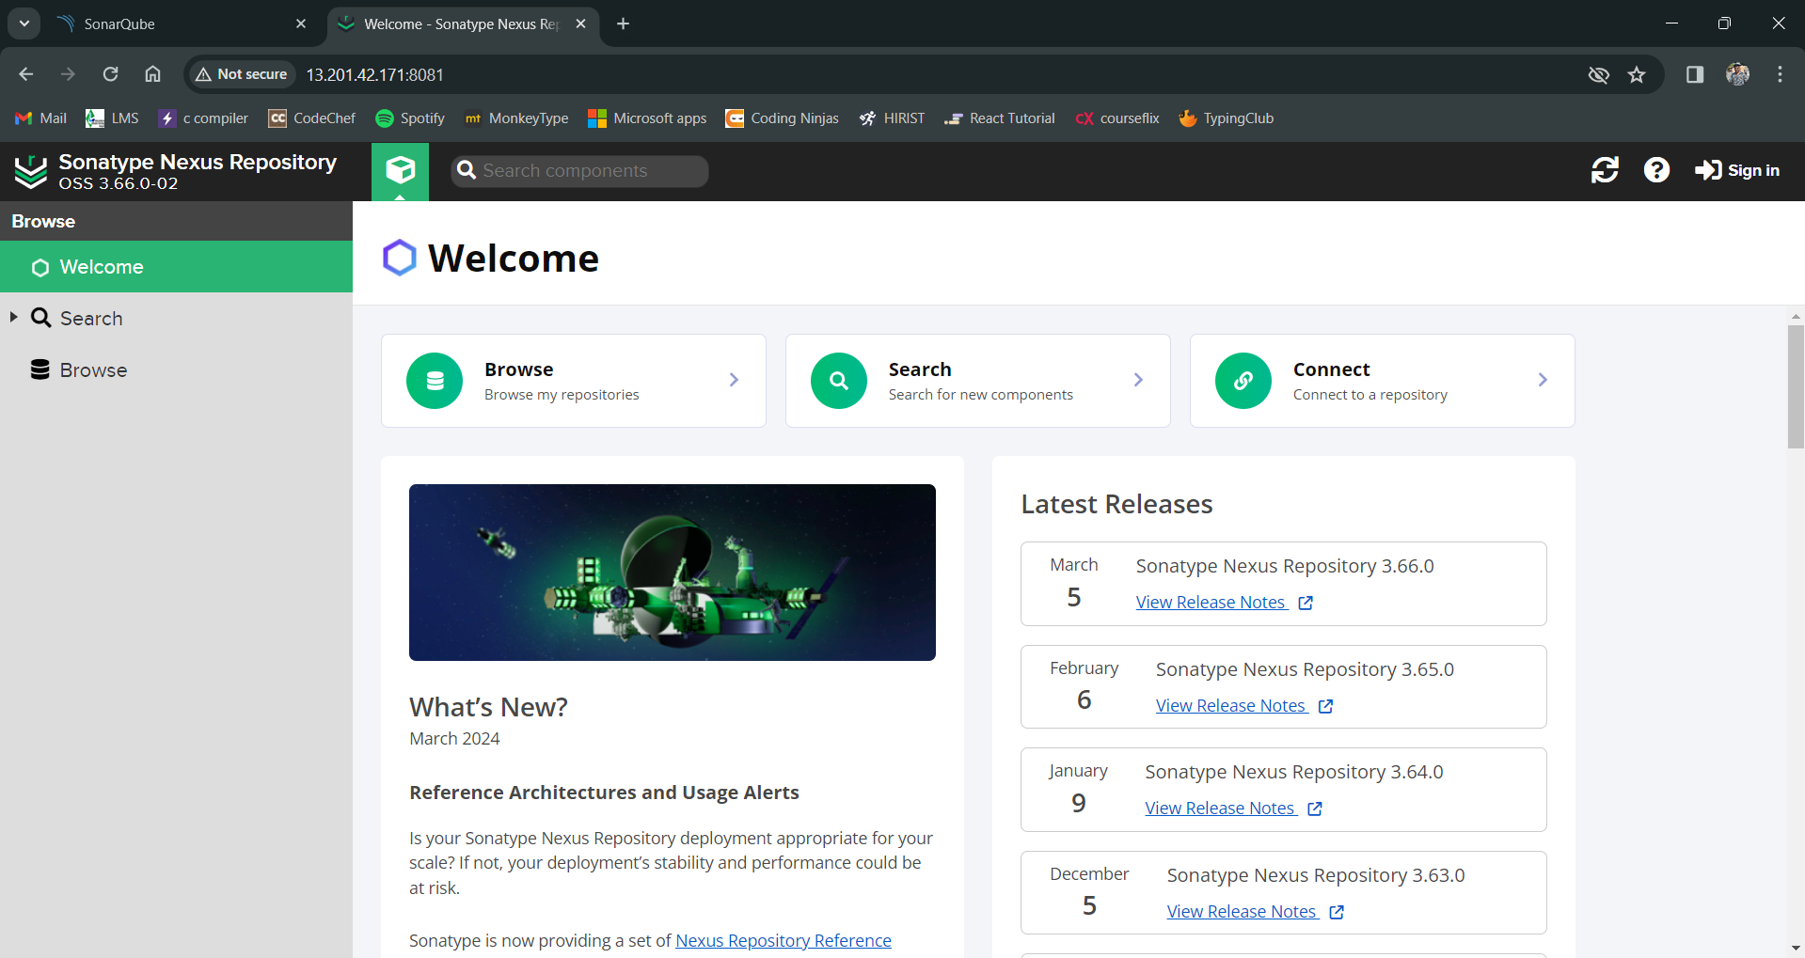

Docker exec -it(interactive terminal)) <container id> /bin/bash for password:  
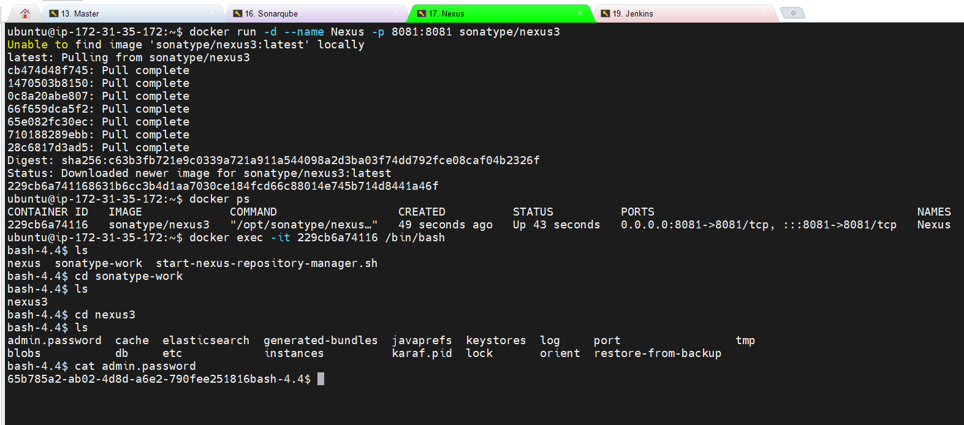

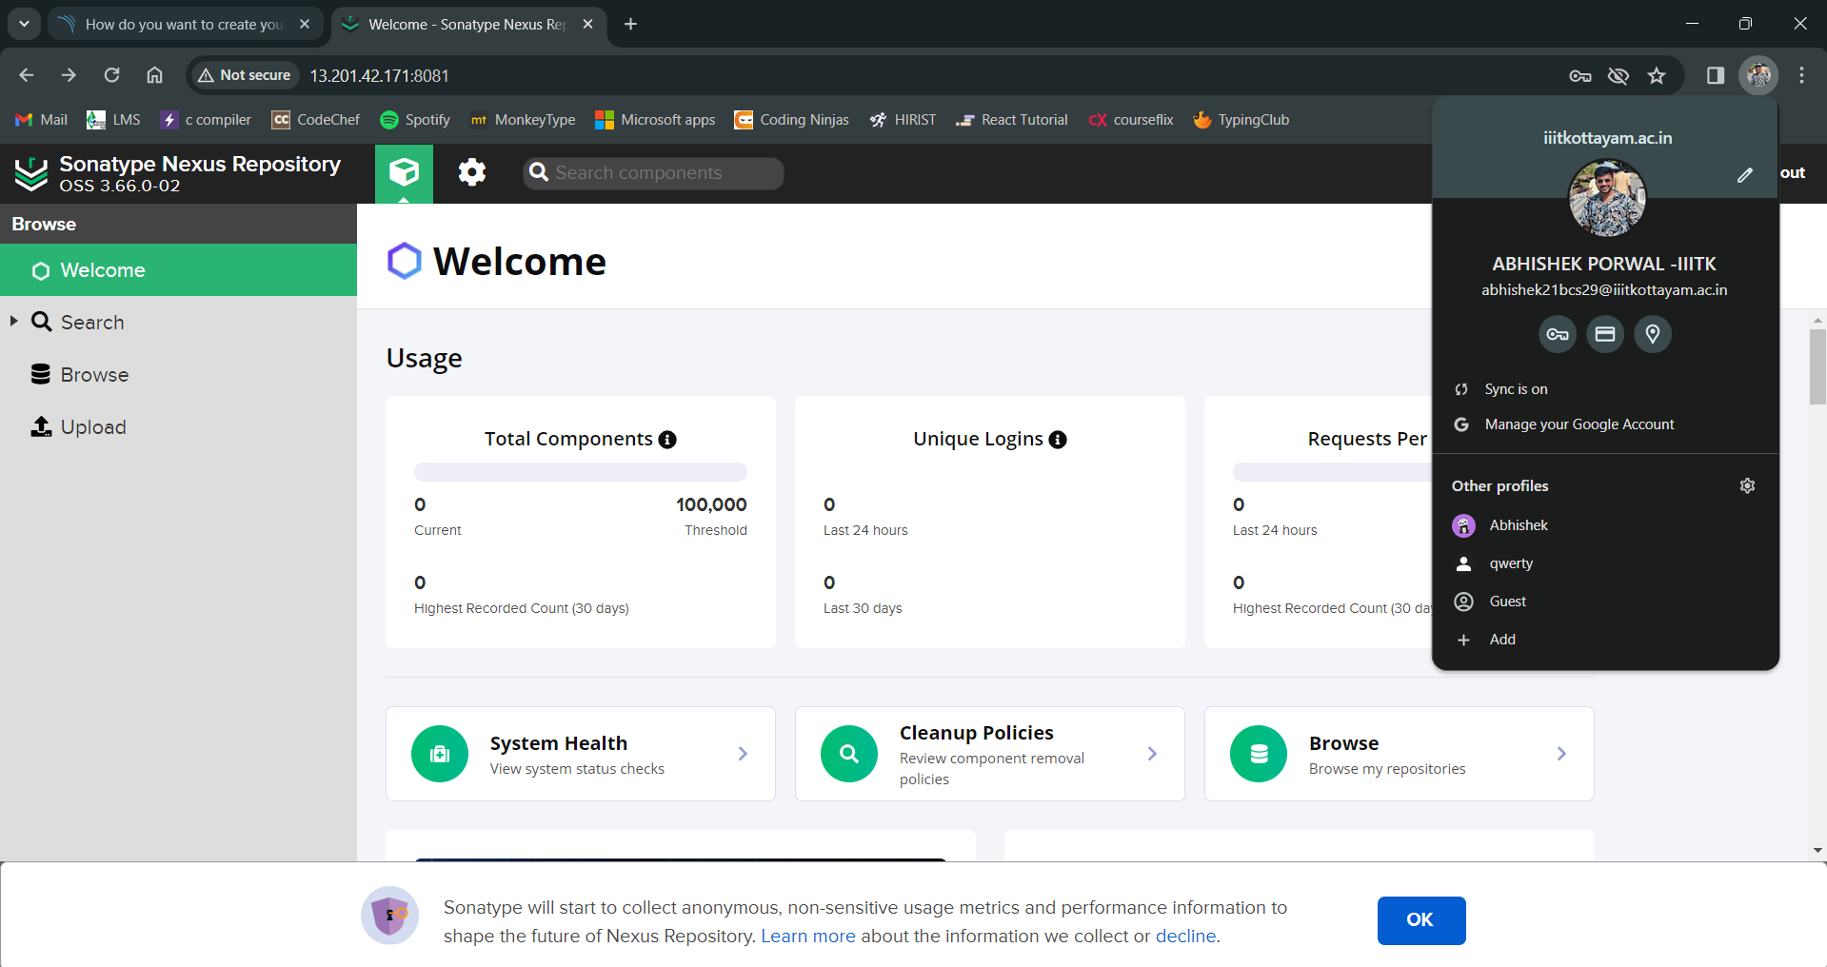

Set up Jenkins:

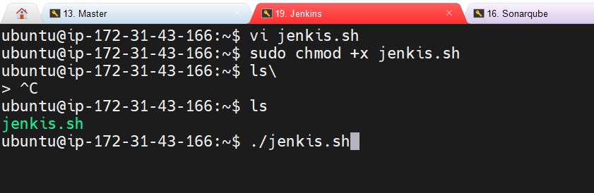

Install docker on Jenkins server

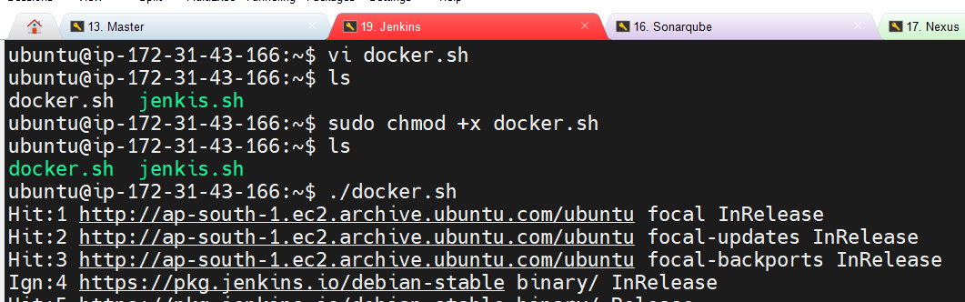

Accesss Jenkins after retrieving password:

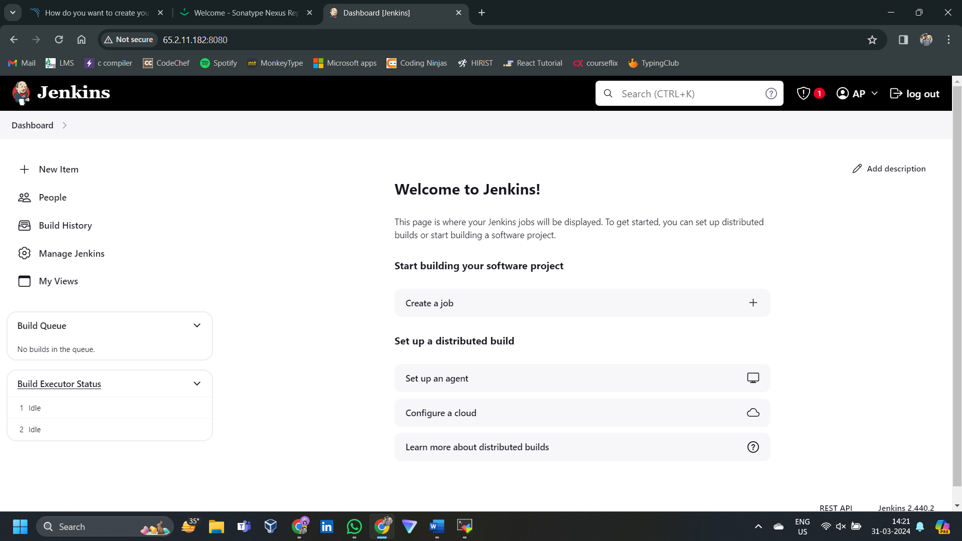

**PHASE 2 : Git repo setup**

**PHASE 3: cicd**

**Install Jenkins plugins:**

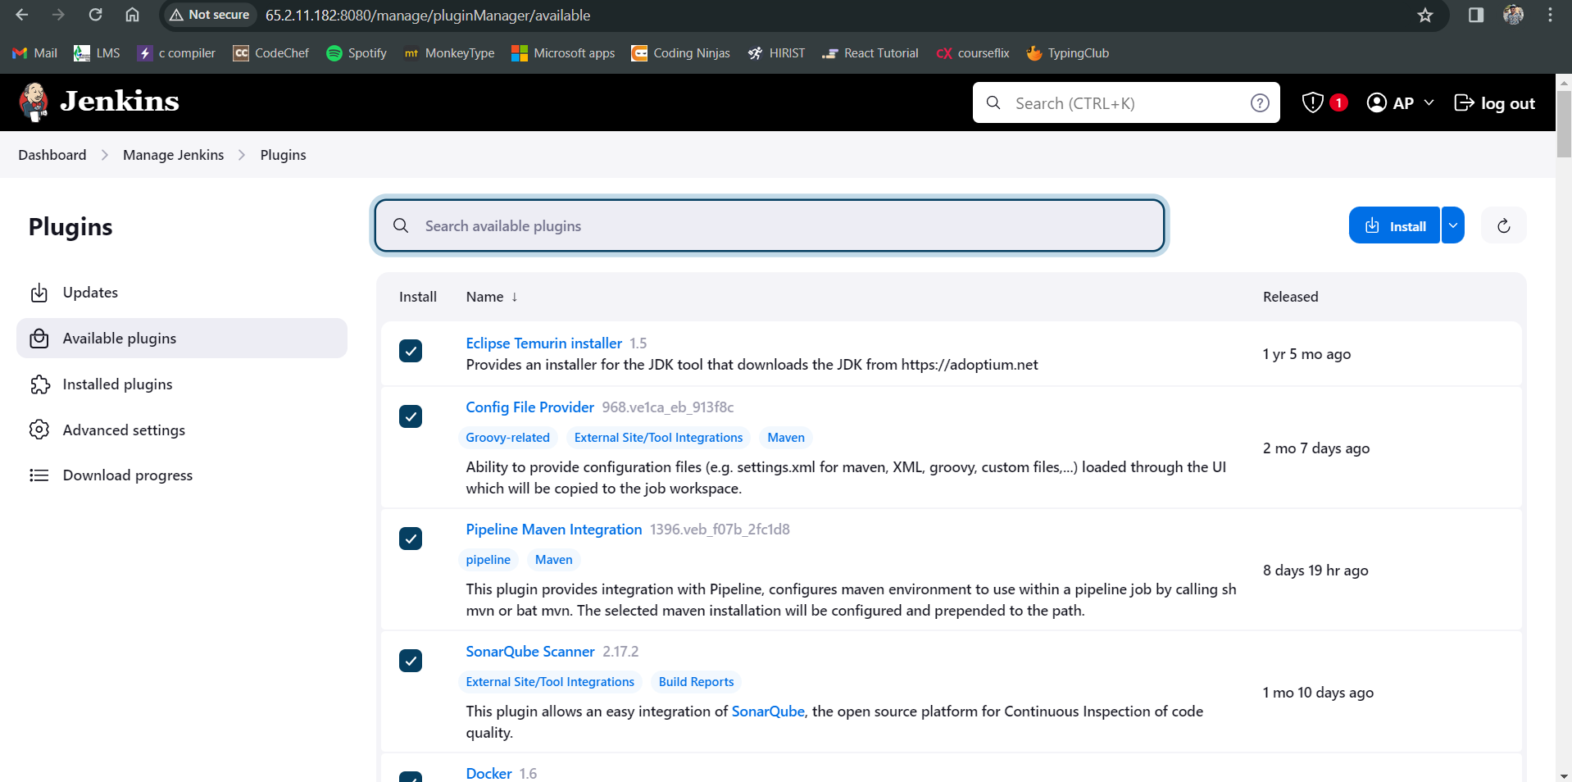

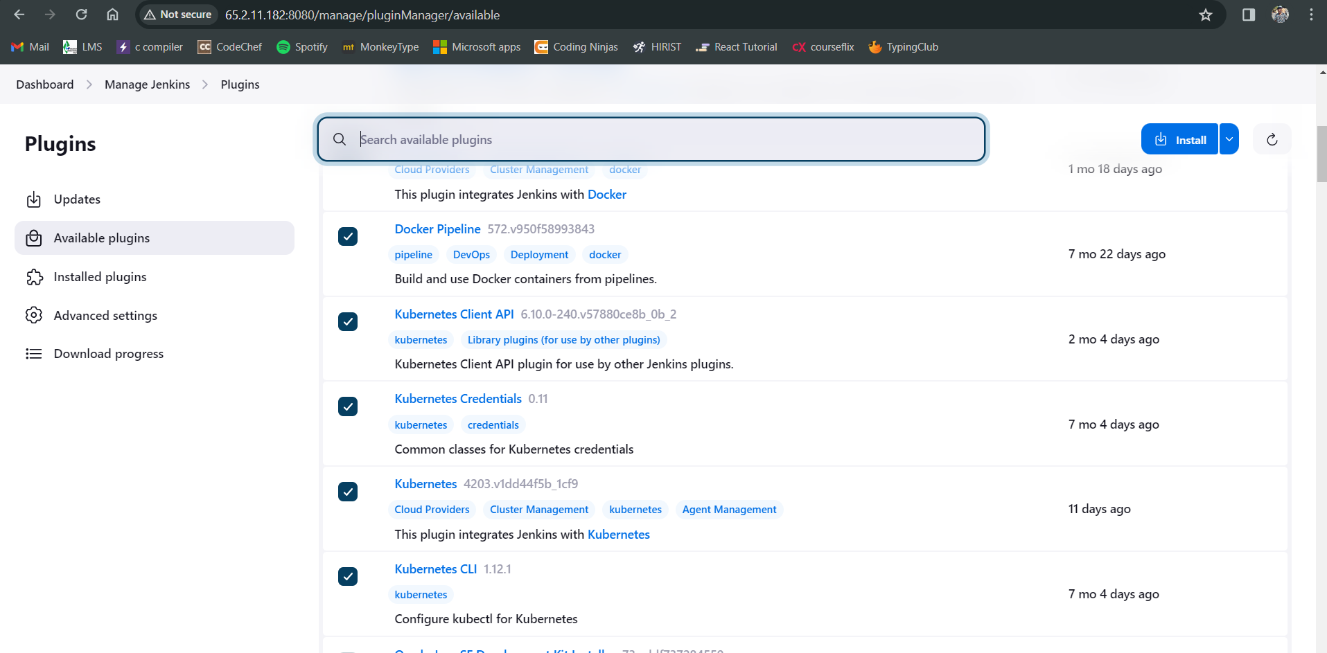

**Installing trivy on Jenkins server as the plugin is not there**

